**Contact Book Project**

*Ramez Medhat*

**الإسم:**

**رامز مدحت حسين السيد سليم - Section 8**

**المعيد:**

**م.م / محمود النامولي**

**Project UML:**

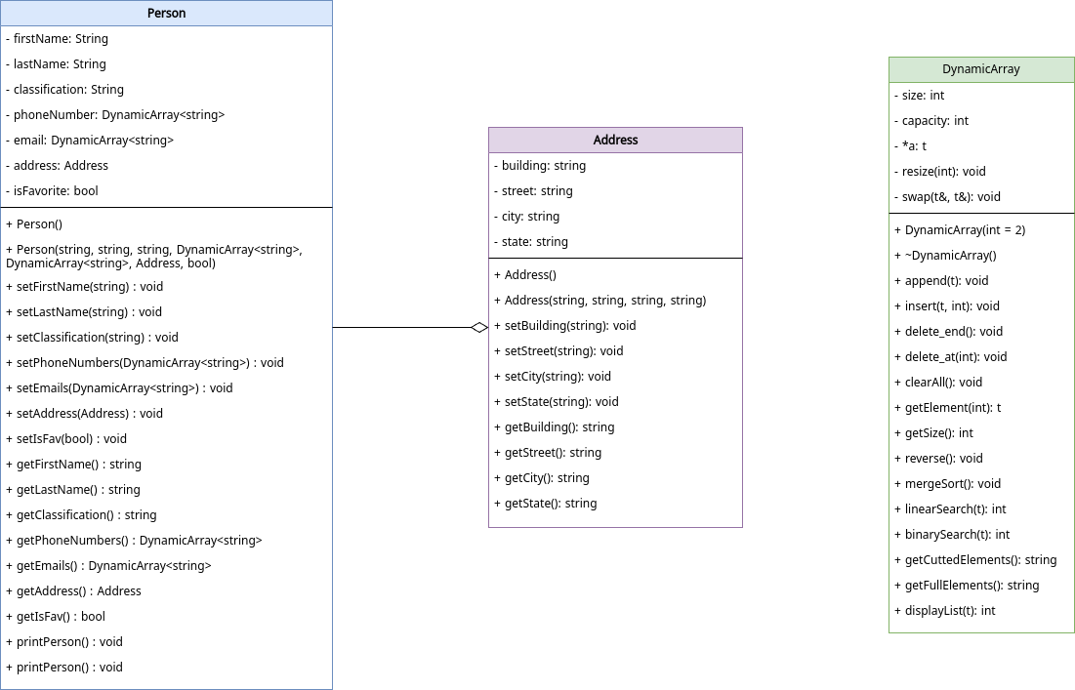

**Project Details:**

**1# Main Page**

At the start of the program the project has no data, you have the option to add a data or import it from a file

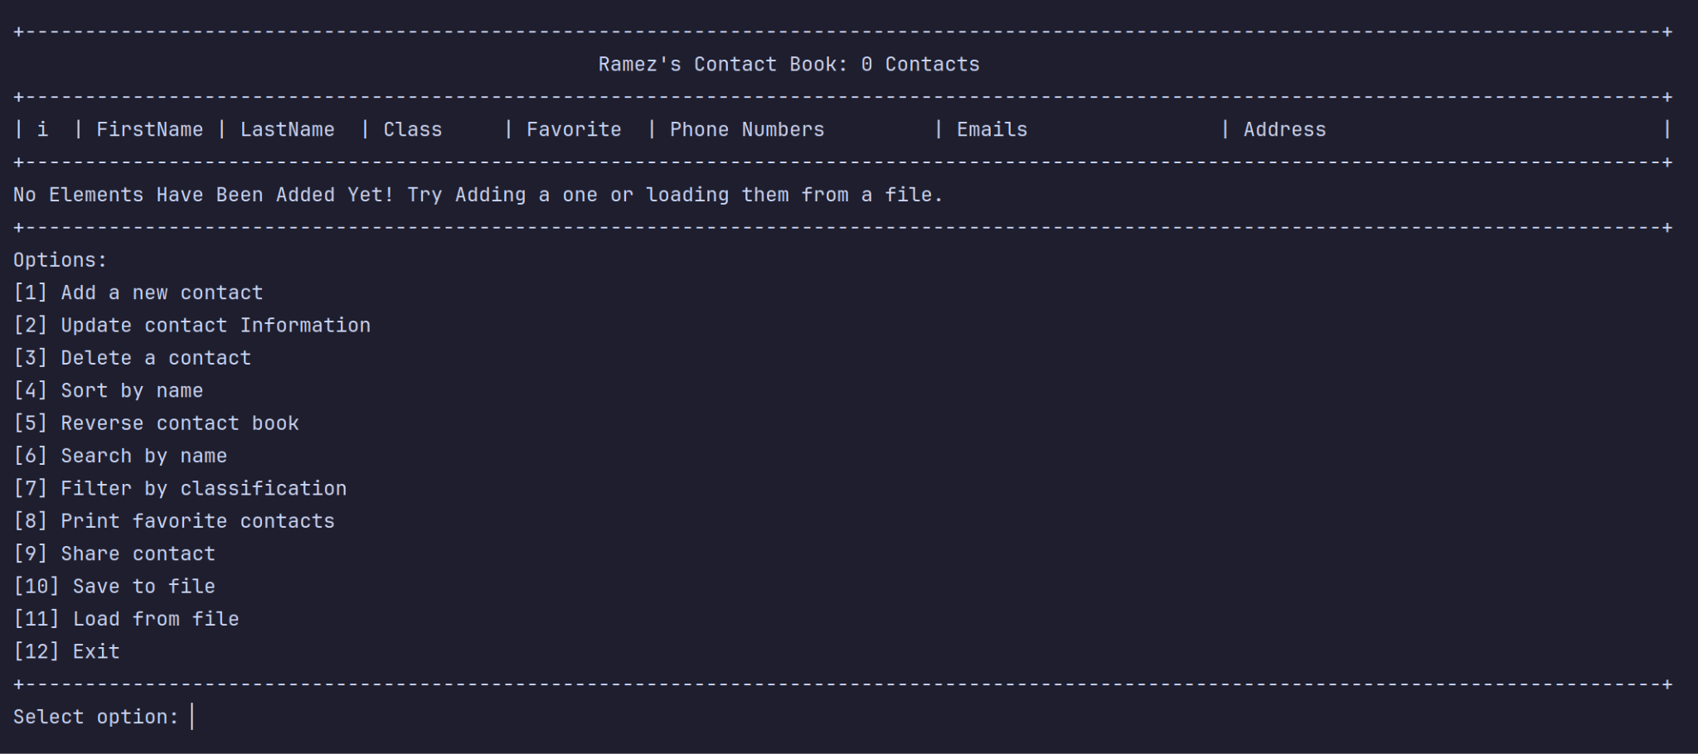

You can also see the different options for the program, If we pressed entered option 11, It will load the data from a file named “contacts.txt”

**2# Loading from a file**

This is the result of loading the data from a file

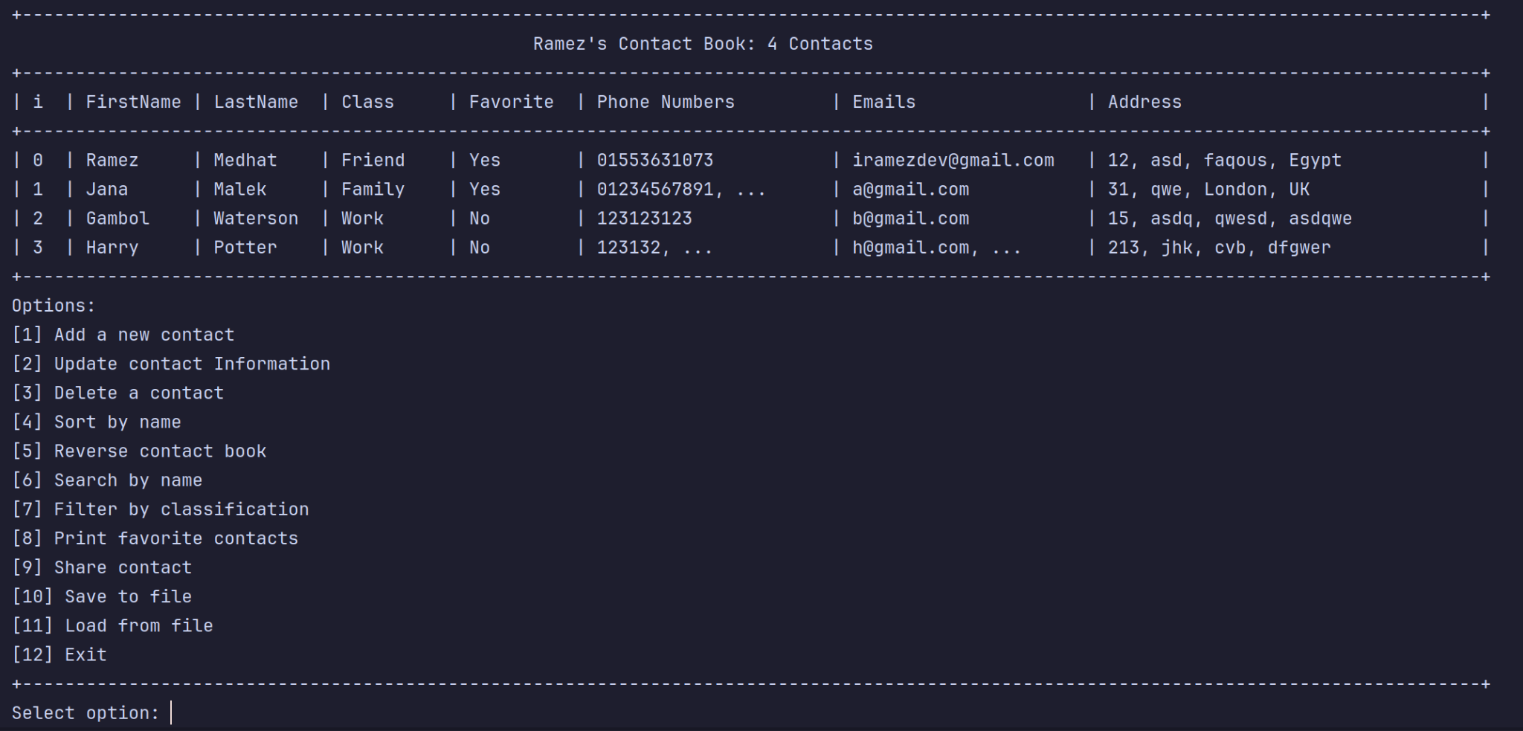

**3# Saving to a file**

At any point of the program we can save the data in the same file, this is the resulting file

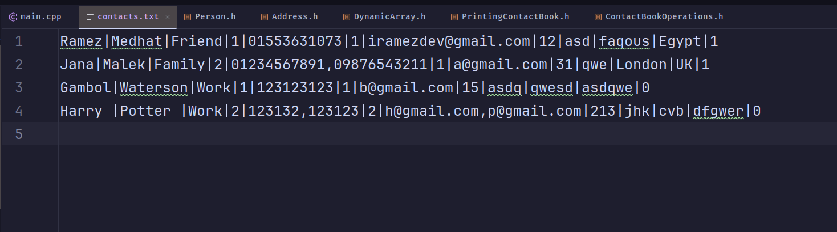

**4# Adding new contacts**

We can add a new contact by selecting option 1, and typing the data one by one.

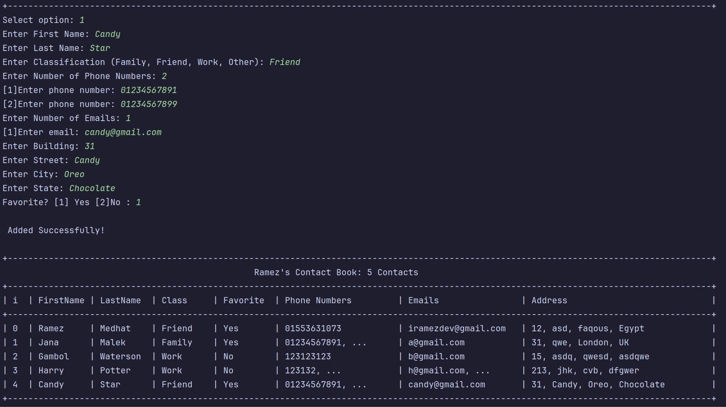

**5# Editing Contact**

We can edit a contact by selecting option 2, and typing the data one by one, if there’s a field we don’t want to edit we don’t type anything and just hit enter.

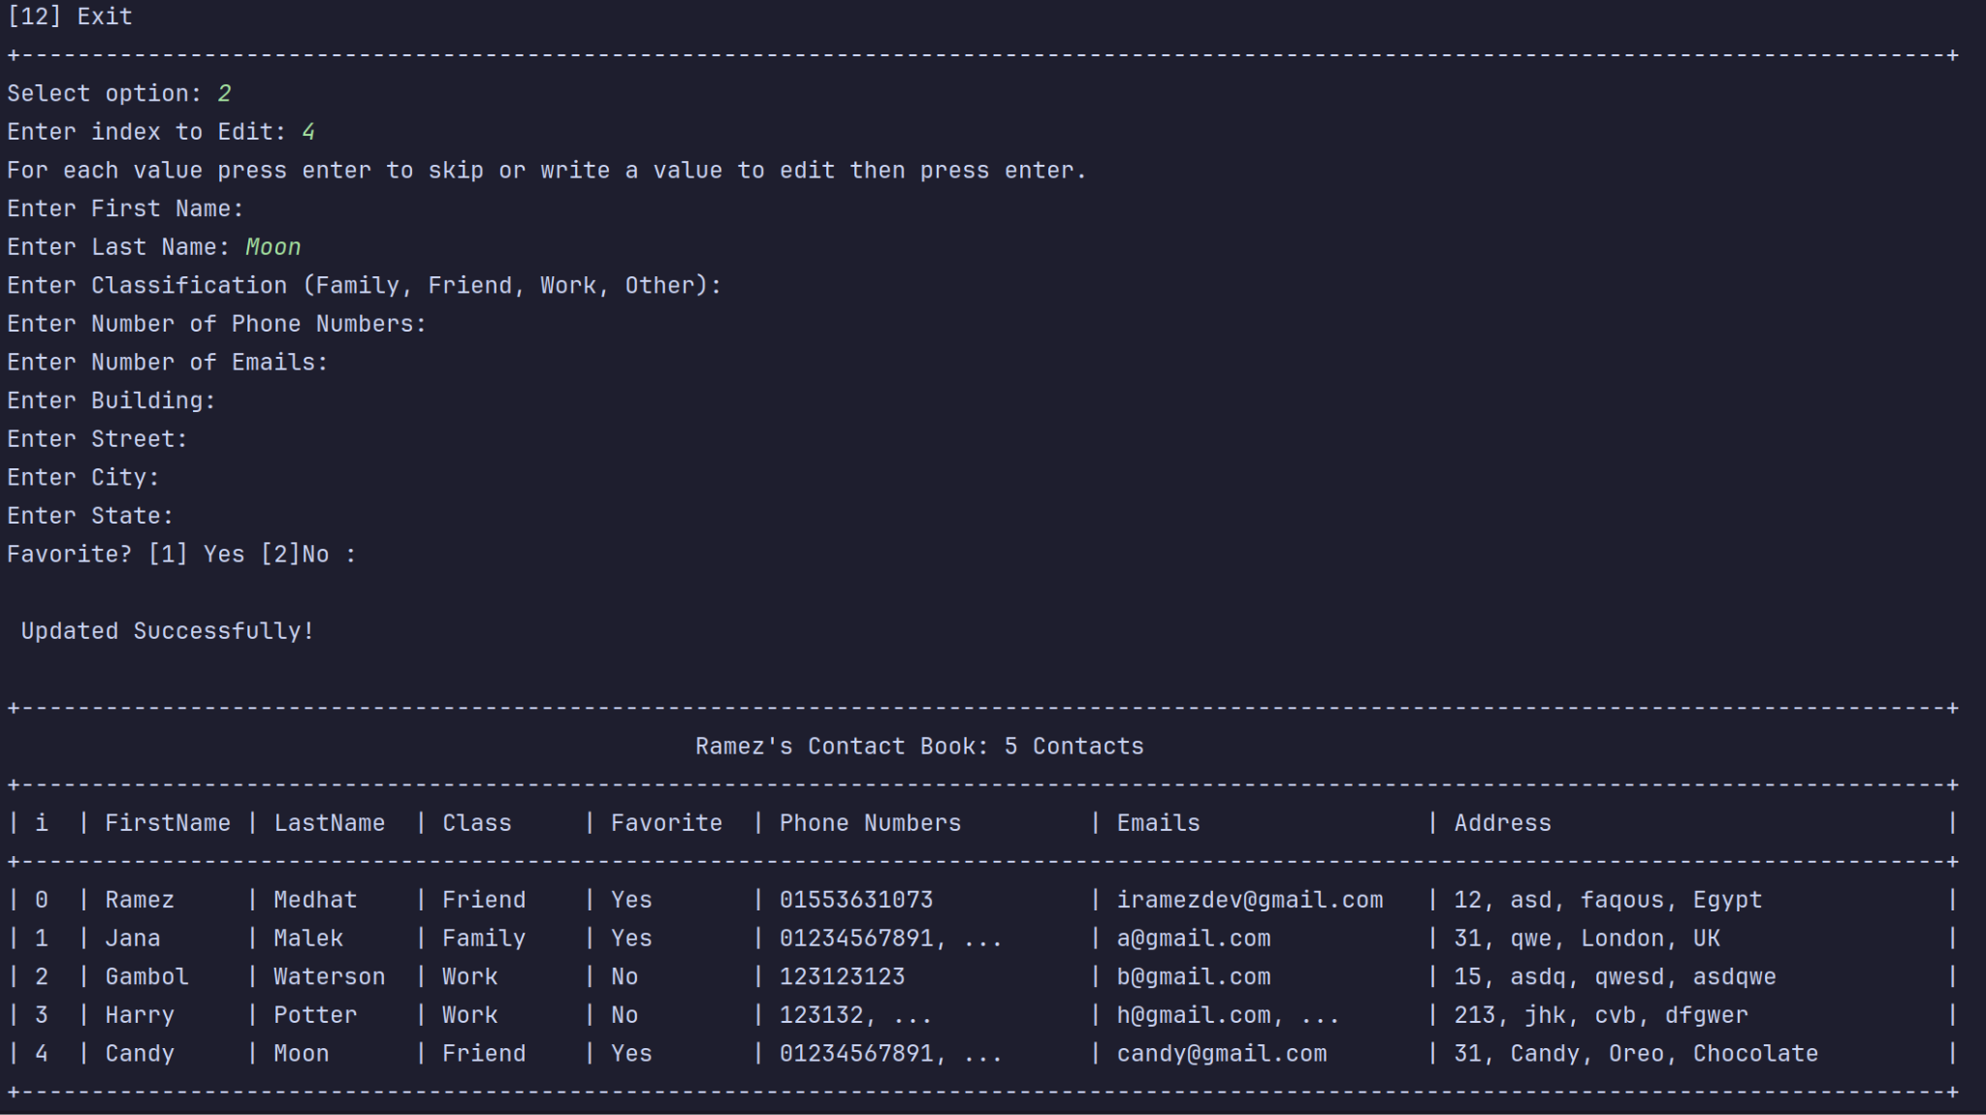

Here we edited the second name only from “Star” to “Moon”.

**6# Deleting Contact**

We can delete a contact by selecting option 3, and type the index of the contact.

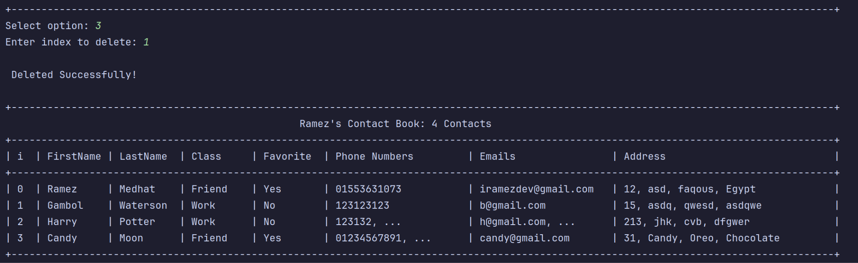

**7# Sorting**

We can sort the contacts by name, select option 4

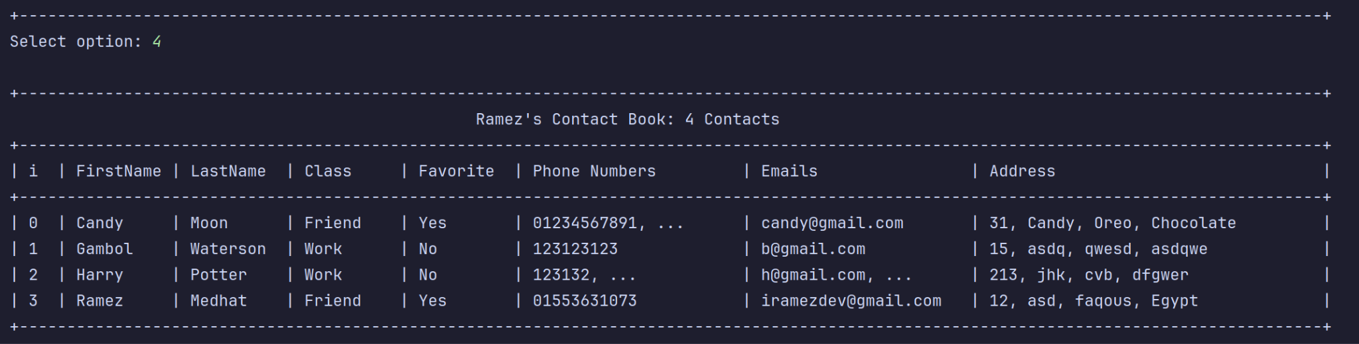

**8# Reversing**

We can reverse the contacts order, select option 5

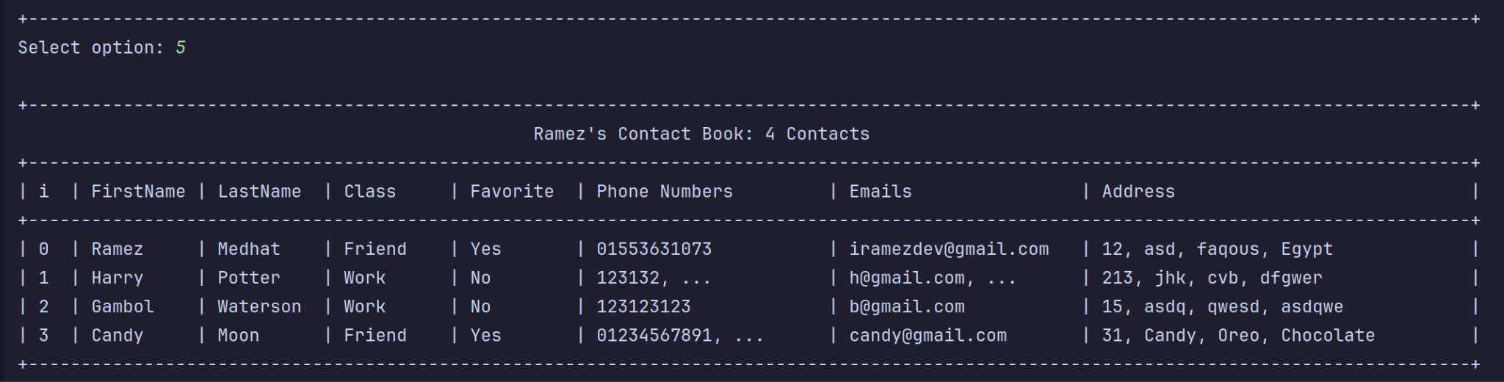

**9# Search**

We can search in the contact book by name, select option 6 and enter the first and last name of the contact.

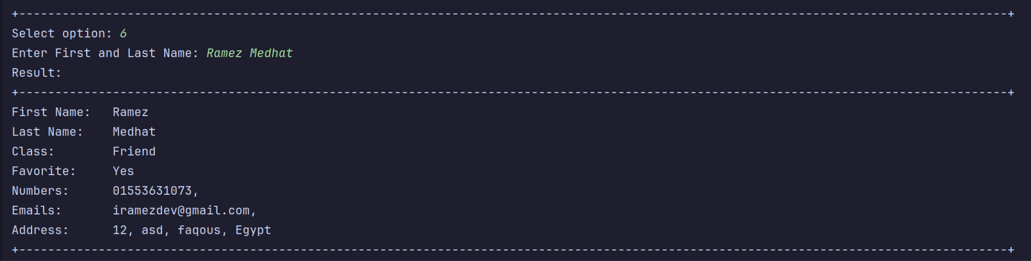

If no such name found, this is the result:



**9# Filter by Classification**

We can filter the contacts by classification, select option 7 and enter the classification filter, a list will show for you like this:

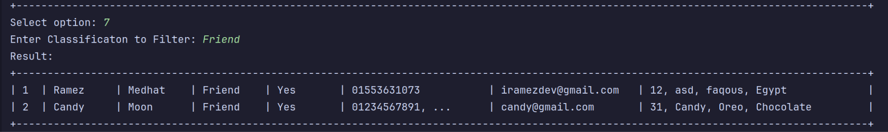

**9# Print favorite contacts**

We can print only the favorite contacts, select option 7.

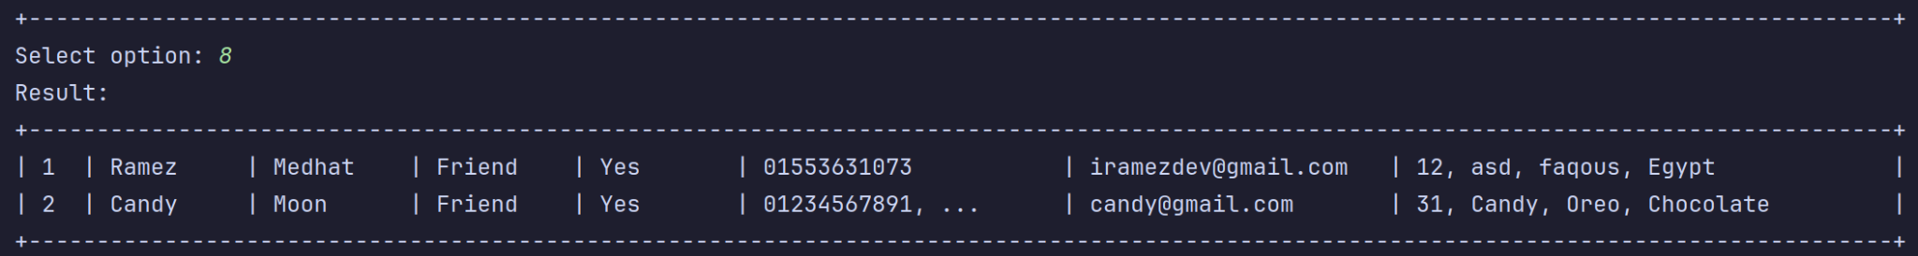

**9# Share a contact**

If you selected option 8 and then entered the index of a contact, It will save the contact details in a file so you can share this file easily.



The file looks like this:

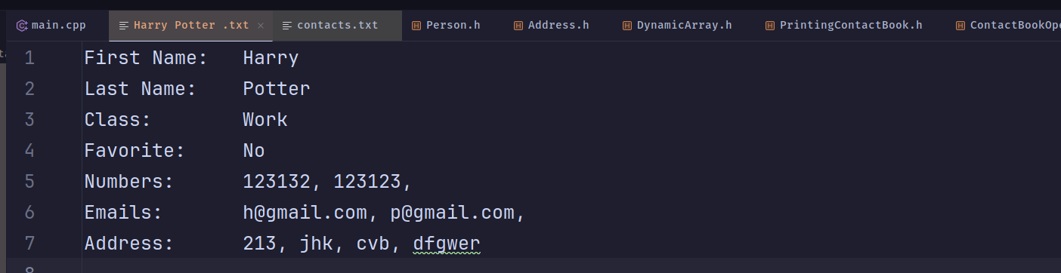

**10# END :)**

Select option 12 to exit the program.

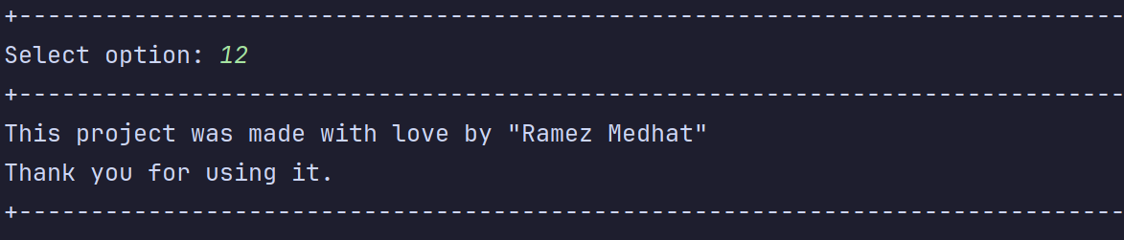

**Thank you for caring ✨🪐**